SIMATS ENGINEERING (SAVEETHA SCHOOL OF ENGINEERING) Department of Computer Science and Engineering
ASSESSMENT TOOL 1 – Constraint-Based Problem Solving
Course Code: | CSA06 | Course Title: | Design and Analysis of Algorithms
CO Assessed: | CO5– Naturalization (BL5,BL6) | Assessment: | Assessment Tool 1 – Constraint Based Problem Solving
Weightage: | 30% of CIA | Total Marks: | 100
CO5 Statement: | Analyze computational problems using backtracking techniques and complexity classes such as P, NP, NP-Hard, and NP-Complete for combinatorial problem solving.
Student Name: | Ishwariya P | Reg. No.: | 192524445
Section / Batch: | 2025 | Date: | 26/8/26

Instructions to Students
• Answer the following question. Total Marks: 100.
• Apply backtracking techniques systematically for combinatorial problem solving.
• Clearly classify problems under P, NP, NP-Hard, and NP-Complete categories wherever required. • Provide proper justification, state-space representation, and complexity analysis for all solutions. • Neat presentation and logical explanation are mandatory.

Question Type | Focus Area | Questions
Constraint Based  Problem Solving | Analyze combinatorial problems using backtracking and complexity classes such as P, NP, NP-Hard, and NP Complete. | Q1

SECTION A – CONSTRAINT-BASED PROBLEM SOLVING
Code of Conduct
I _Ishwariya P(192524445)_________________________ (Name / Reg No) certify that this submission is my original work and that I have adhered to the guidelines specified for this assessment. I understand that any violation of academic integrity rules will result in disciplinary action.
Signature of the Student: _________________________

RUBRICS FOR CALCULATION
Criteria | Wt. | Level 4 – Exemplary | Level 3 –  Proficient | Level 2 –  Developing | Level 1 –  Beginning
Problem  Understanding | 25% | Clearly defines the  problem and identifies all relevant constraints  accurately | Identifies most  constraints with  minor gaps | Partial understandi ng; misses key  constraints | Fails to identify constraints  correctly
Constraint  Analysis | 25% | Analyzes constraints  effectively and prioritizes them logically | Provides reasonable analysis with some prioritizatio n | Limited analysis; weak prioritization | No meaningful analysis or  prioritization
Solution  Development | 25% | Develops optimal and feasible solutions  satisfying all constraints | Develops workable solutions with minor limitations | Solutions partially  satisfy constraints | Solutions do not meet constraints
Application of Concepts | 15% | Effectively applies  appropriate concepts, methods, or tools | Applies concepts  with minor errors | Limited application; requires guidance | Unable to apply relevant  concepts
Justification | 10% | Provides strong  justification for decisions with logical reasoning | Provides justification with some clarity | Weak or unclear  justification | No justification provided

Marks Evaluation:
Criteria | Wt. | Level 4 –  Exemplary | Level 3 –  Proficient | Level 2 –  Developing | Level 1 –  Beginning
Problem Understanding | 25%
Constraint Analysis | 25%
Solution Development | 25%
Application of Concepts | 15%
Justification | 10%
Total Marks (100):

Faculty In-charge | Course Coordinator | Head of Department
Name: | Name: | Name:
Signature: _______________ | Signature: _______________ | Signature: _______________
Date: ___________________ | Date: ___________________ | Date: ___________________

Aim

To solve the Exact Cover Problem using a backtracking-based constraint satisfaction approach, selecting subsets such that every element of the universe is covered exactly once, while using pruning to eliminate invalid selections.

Algorithm

- Convert the universe and all subsets into sets.
- Create a mapping from each element to the subsets containing it.
- Select an uncovered element with the fewest available subsets.
- Try each subset containing that element.
- Check the constraints:
  - The subset must contain only uncovered elements.
  - It must not overlap with already selected subsets.
- Add the valid subset to the solution and mark its elements as covered.
- Recursively solve the remaining problem.
- If all elements are covered, return the selected subsets.
- If no valid subset exists, backtrack and try another choice.
- This pruning avoids exploring redundant or invalid combinations.

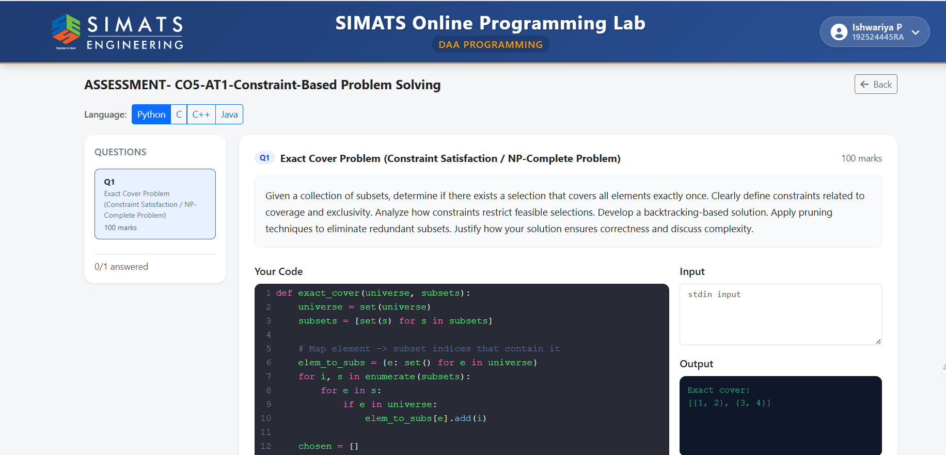

Python Code
def exact_cover(universe, subsets):
universe = set(universe)
subsets = [set(s) for s in subsets]

# Map each element to subsets containing it
elem_to_subs = {e: set() for e in universe}

for i, s in enumerate(subsets):
for e in s:
if e in universe:
elem_to_subs[e].add(i)

chosen = []

def backtrack(remaining):
# All elements covered
if not remaining:
return True

# Choose the most constrained element
element = min(
remaining,
key=lambda e: len([
i for i in elem_to_subs[e]
if subsets[i].issubset(remaining)
])
)

# Try possible subsets
for i in elem_to_subs[element]:
s = subsets[i]

# Pruning: subset must be completely inside remaining
if not s.issubset(remaining):
continue

chosen.append(i)

# Cover selected elements
if backtrack(remaining - s):
return True

# Backtrack
chosen.pop()

return False

if backtrack(universe):
return [subsets[i] for i in chosen]

return None

# Input
universe = {1, 2, 3, 4}
subsets = [
{1, 2},
{1, 3},
{2, 4},
{3, 4}
]

result = exact_cover(universe, subsets)

if result:
print("Exact cover:")
print(result)
else:
print("No exact cover exists")

Result

For the given example:
Universe = {1, 2, 3, 4}

Subsets = {{1,2}, {1,3}, {2,4}, {3,4}}
The output is:
Exact cover:
[{1, 2}, {3, 4}]
Thus, an exact cover exists, and the selected subsets {1,2} and {3,4} cover every element exactly once.

